Decentralized traceability and direct marketing of agriculture supply chains with QR scanner

ABSTRACT:
The decentralized traceability and direct marketing platform for agriculture supply chains. Globalized delivery of manufacturing and agricultural production offer renewed attention to the health, efficiency, and validation of many vital criteria in the food and agricultural supply chain. That numbers of food safety and corruption hazards have generated an enormous need of an efficient traceability solutions which acts as an essential quality managements tools ensuring to enough product’s safety within the agriculture supply chain. Block chain is the revolutionary technological method, which provides the ground breaking result for commodity traceableness in agriculture and in food supply chains. Today's agricultural supplying chains are complicated ecosystems mixing several stakeholders making it difficult to validate several significant requirements mainly towards nation of first origin, crop growth phases, quality standards compliance, and yield monitoring. This paper proposes a strategy that levitates the block chain and conducts business operations effectively across the agricultural supply chain for tracking crop prices and traceability. The proposed framework solution discards the need for trusted centralized authority, intermediaries and offers records of the transactions, improving efficient science and safety with high integrity and reliability. All transactions are registered and then stored in block chain’s unchangeable ledger with linkages to a decentralized le network, thereby ensuring vary high degree of traceability and transparency in the supply chain ecosystem in a stable, reliable and in efficient manner.
Keywords: Decentralized, Traceability, Direct marketing, Agriculture, Supply chains

STATEMENT ABOUT THE PROBLEM
The globalized nature of agricultural production and manufacturing has intensified concerns regarding food safety, efficiency, and validation within supply chains. The rising incidents of food safety breaches and corruption highlight the dire need for efficient traceability solutions as vital quality management tools. Contemporary agricultural supply chains are intricate, involving multiple stakeholders, making verification of origin, growth phases, and compliance challenging. Existing systems, reliant on centralized authorities and intermediaries, lack transparency and integrity. There's a pressing demand for a decentralized, reliable solution to ensure transparency, traceability, and efficiency in agricultural supply chains.
WHY IS THE PARTICULAR TOPIC CHOSEN?
The topic was chosen due to increasing global concerns about food safety, authenticity, and the inefficiencies in agricultural supply chains. With rising instances of food corruption and safety hazards, there's an urgent need for reliable traceability solutions. Blockchain offers a decentralized, transparent, and immutable method to address these challenges. Its adoption in the agricultural sector can enhance trust, verify product origins, and ensure quality compliance. Moreover, the complexity of modern supply chains necessitates innovative solutions like blockchain to ensure transparency and efficiency.
SCOPE:
The project aims to revolutionize agricultural supply chains using blockchain technology. By decentralizing traceability and eliminating the need for intermediaries, it ensures high-quality standards, enhanced product safety, and verifiable origin tracking. The proposal leverages blockchain's immutable ledger, recording all transactions and offering unparalleled transparency and reliability. This approach simplifies complex supply ecosystems, making crop price tracking, compliance, and yield monitoring more efficient, ultimately fostering a trustworthy, transparent, and streamlined supply chain environment.

OBJECTIVE OF THE PROJECT:
The project aims to revolutionize the agricultural supply chain by integrating blockchain technology, enhancing traceability and transparency. This decentralized platform addresses food safety and corruption concerns, ensuring product safety and quality standard compliance. By eliminating the need for centralized authorities and intermediaries, the strategy offers an immutable record of transactions, bolstering efficiency, security, and trustworthiness. It streamlines the complex supply chain ecosystem, ensuring accurate tracking of crop prices, origin, growth stages, and yield monitoring, fostering a reliable and efficient system.
EXISTING METHOD
There is no computerized system in place to trace the cost of agriculture. Agricultural products cannot be obtained by the farmer.72 percent of the population in India is dependent on the farming industry. Farmers get enormous quantities of crop manufacturing, but they have not got the correct price because they can survive the present circumstances. So they are suicide and nothing is done by the government. So we are attempting to fix this issue in the suggested scheme by tracing the cost of the agricultural product from farmer to client.
3.2 Disadvantages
- Complexity in Implementation: Setting up decentralized systems can be intricate, demanding expertise and resources, making it challenging for smaller agricultural players.
- Interoperability Issues: Ensuring compatibility among various decentralized platforms and technologies can be a hurdle, potentially leading to data silos and inefficiencies.
- Scalability Constraints: Expanding a decentralized system to accommodate a growing number of users and transactions can be challenging, causing performance issues.
- Security Risks: Decentralized systems are not immune to security threats like smart contract vulnerabilities and hacking, posing risks to data integrity and user trust.

3.3 Proposed System
In proposed system we are using a Block chain helps which helps in maintaining the integrity and transparency of the whole process right from inception of crop details. Blockchain helps in managing and tracing the crop information transparent distribution.
3.4 Advantages
- Enhanced Transparency: Decentralized traceability allows consumers to track the journey of agricultural products from farm to table, fostering trust.
- Reduced Fraud: Direct marketing eliminates intermediaries, reducing the risk of counterfeit goods and fraud in the supply chain.
- Fair Pricing: Farmers receive a fair share of profits by selling directly to buyers, avoiding price manipulation by middlemen.
- Efficient Logistics: Real-time data improves inventory management and logistics, reducing wastage and optimizing distribution.
3.5 work Flow of Proposed system
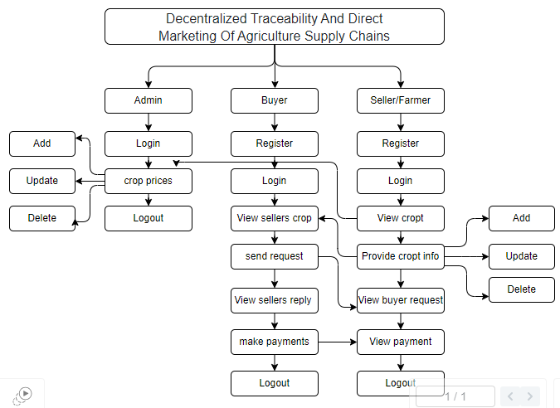
SOFTWARE FRONT END REQUIREMENTS

H/W CONFIGURATION:

Processor - I3/Intel Processor
Hard Disk - 160GB
Key Board - Standard Windows Keyboard
Mouse - Two or Three Button Mouse
Monitor - SVGA
RAM - 8GB
S/W CONFIGURATION:
- Operating System : Windows 7/8/10
- Server side Script : HTML, CSS, Bootstrap & JS
- Programming Language : Python
- Libraries : Flask, Pandas, Mysql.connector, Os, Smtplib, Numpy
Web3, truffle, Ganache
- IDE/Workbench : PyCharm
- Technology : Python 3.6+
- Server Deployment : Xampp Server

MODULES/IMPLEMENTATION
Admin:
- Login: The admin will login with default email and password.
- Crop price: The admin is the person he/ she will add the crop price for each and every crop details with that crop name, category, maximum cost, minimum cost and quantity.
- Logout: Allows the admin to log out securely.
Buyer:
- Register: The buyer will register with their details like name, email, password, address, contact, so after that the buyer will login.
- Login: After registration the buyer will login with their details.
- View Seller's Crop Information: Once the sellers will add the details the buyer can view those details here.
- Send Request to Seller: If the buyer wants the details of crop then buyer will send request to seller.
- View Seller Requests: Displays responses from sellers to the buyer's requests.
- Make Payment: Once the seller accept the request for the crop the buyer has to pay the amount for that crop.
- Logout: Allows buyers to logout securely.
Seller:
- Register: The seller will register with their details like name, email, password, address, contact, so after that the seller will login.
- Login: After registration the seller will login with their details.
- Provide Crop Information: The seller will add there crop details like (crop name, crop category, and quantity and quality).
- View Buyer Requests: When the buyer will send the request for the crop, here the buyer will view and he/she has to accept the request.
- View Payments: Once the buyer will pay the amount for the crops. The seller can view the details of the payment.
- Logout: Allows sellers to logout securely.

